# C:\Users\dell\OneDrive\Desktop\computer science\numl logo.png

**NAME**: Muhammad Talha Ansari

**SUBJECT**: Digital logic design

**ROLL #** 024

**ASSINGED BY** : Sir Rafay

# Prove Laws of Boolean algebra

**Identity Law:**

Whenever we OR ‘0’ with any variable its identity remains same and when we AND ‘0’ with any variable its identity remains same.

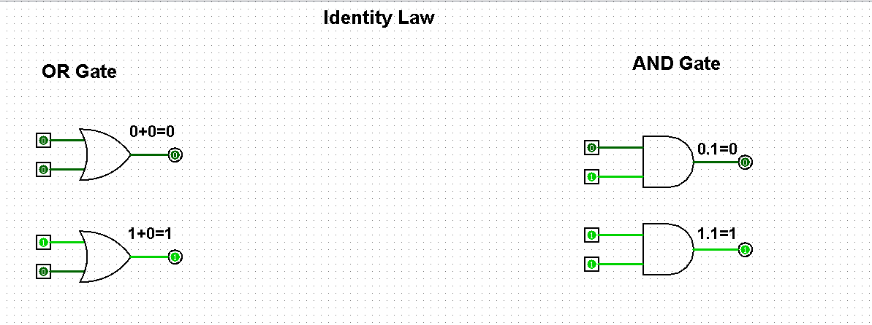

**Idempotent Law:**

If a variable is OR with itself result would be same as it was at the start and if a variable is AND with itself result would be same as it was at the start.

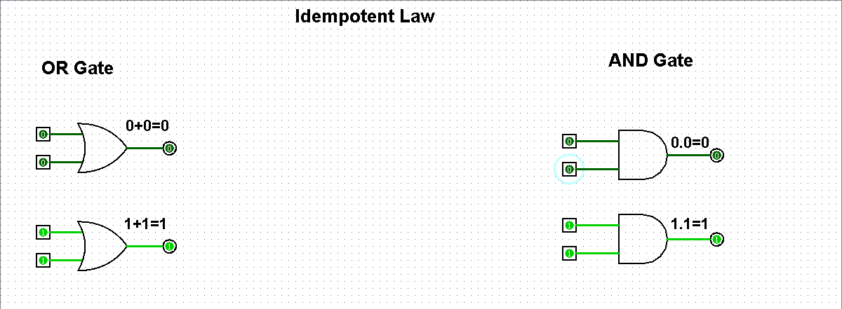

**Complement:**

If a variable is OR with its complement result would be **1** and if a variable is AND with its complement result would **0**.

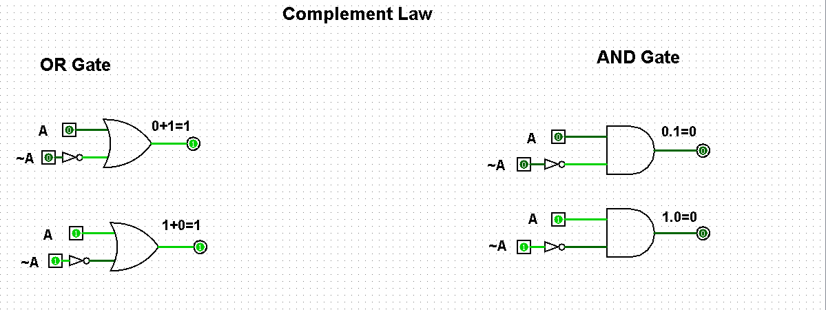

**Involution Law:**

If a number is negated twice then we get the same number.



**Associative Laws**

The associative law of addition of three variables is expressed as

A + (B + C) = (A + B) + C

The associative law of multiplication of three variables is expressed as

A(BC) = (AB)C

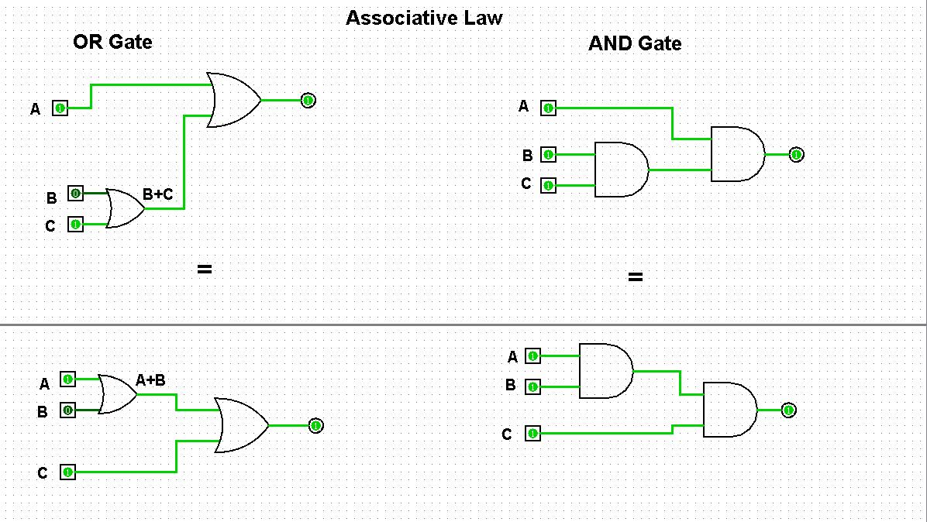

**Distributive Law**

The distributive law of three variables is expressed as follows:

* Distribution of Multiplication over Addition

A· (B+C) = (A·B) + (A·C)

* Distribution of Addition over Multiplication A+ (B·C) = (A+B) · (A+C)

